**AN INVESTIGATION INTO HOW SOCIAL ENTREPRENEURSHIP AFFECTS SOCIAL CHANGE AND SUSTAINABLE DEVELOPMENT**

**Table of Contents**

Chapter 3: Methodology 3

3.1 Introduction 3

3.2 Research Onion 3

3.3 Research Philosophy 4

3.4 Research approach 4

3.5 Research Strategy 5

3.6 Research Choices 6

3.7 Time Horizon 7

3.9 Data analysis 9

3.10 Research ethics 9

3.11 Research limitations 10

3.12 Conclusion 11

Chapter 4: Analysis and findings 12

4.1 Introduction 12

4.2 Analysis 12

4.3 Findings 29

4.4 Summary 36

References 37

# Chapter 3: Methodology

## 3.1 Introduction

The methodology chapter will highlight the different research methods used for data collection to provide an in-depth analysis of the effects of social entrepreneurship on "social change and development". It will further focus on providing an overview of the study using quantitative data gathered from primary sources. The stages of data collection will be represented by a research onion. Furthermore, this chapter will discuss the research philosophy, strategy, and time horizon for data evaluation. Thereafter, certain research ethics and limitations will be identified for future guidance.

## 3.2 Research Onion

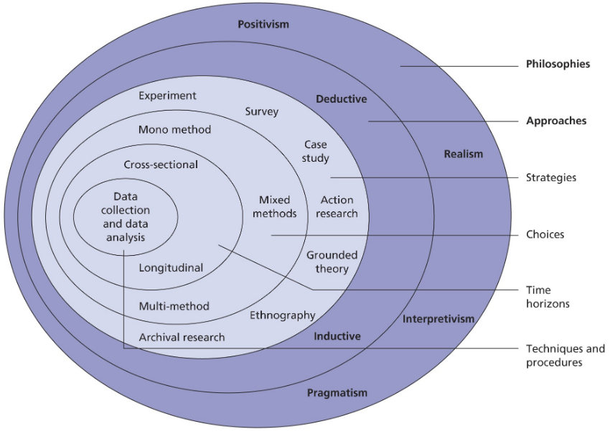

**Figure: Research Onion**

(Source: Saunders and Tosey, 2012)

## 3.3 Research Philosophy

A positivist philosophy has been used in this study because it provides valuable information to understand the context of social entrepreneurship. Positivism places a strong emphasis on objective, observable, and quantifiable data, it is a well-suited philosophy for researching the effects of social entrepreneurship on social change and sustainable development. The requirement to quantify the practical effects of social entrepreneurship on environmental and social outcomes is consistent with positivism's emphasis on empirical data. Using a positivist philosophy, this study may assess how well different social entrepreneurship projects promote social change and advance sustainable development by using statistical tools and quantifiable indicators. Positivism enables the study of social entrepreneurship to analyse theories and draw potential conclusions that can be applied broadly (Park et al. 2020). Additionally, positivism encourages study replication, which helps academics confirm results in many locations and contexts, a critical component in comprehending the wider implications of social entrepreneurship.

Positivism philosophy is especially helpful for assessing the observable results of social entrepreneurship projects, including the number of impacted beneficiaries or the decrease in carbon emissions. Positivism emphasises measurable outcomes, it is simpler to evaluate how well social entrepreneurship promotes sustainable development. Measurable results, including advancements in health, education, or environmental preservation, offer verifiable proof of accomplishments or opportunities for development. A positivist philosophy makes it possible to replicate research in other settings, guaranteeing that conclusions on the influence of social entrepreneurship on social change are trustworthy and applicable to other areas or industries (Alharahsheh & Pius, 2020). By helping to find patterns and connections, positivism helps academics forecast the potential effects of specific social entrepreneurship tactics on future environmental or social consequences. Apart from its benefits, positivism was not able to provide abstract ideas, principles surrounding the specific observable relationship and facts as well as significant principles.

## 3.4 Research approach

A research approach is basically a method of “reasoning” which includes drawing “general conclusions” from a particular observation. It is based on the problems of the research along with assumptions of the researchers. As this research paper is based on primary quantitative analysis, an inductive approach has been selected for this research paper. An inductive approach is a process which includes illustration of the general conclusion from a particular observation. The inductive approach is used to generate new theories which are mainly used in grounded theories. It also motivates and encourages critical thinking along with deeper understanding. For this particular research paper, an inductive approach has been chosen because it helps in making the research more valuable and powerful. The reason behind choosing an inductive approach and not the deductive approach is because it helps the researchers to generate and develop new theories based on the observed data. On the other hand, a deductive approach provides the data by testing the existing theories and hypotheses which has limited creativity. It converts the small observation into bigger conclusions. It is a great option in terms of developing new theories and understating the complexities of the situations while researching. This study is focusing on the primary quantitative data for the investigation on “how social entrepreneurship affects social change and sustainable development” The methodology will adapt a survey to gather data about the research. The responses will be quantitatively analysed to identify the patterns as well a correlation between social entrepreneurships initiatives. This will help in the collection of the data on the outcomes of the “social enterprises” for example- environmental impacts, job creation and also the community development. This review will be helpful in the development of the conceptual model which will describe the relationship between these elements. This approach is helpful in enhancing the reliability of the findings. The descriptive study has provided perspectives and points of vows of the respondents. The primary quantitative approach aims to present empirical evidence to the research on the role of social entrepreneurship in terms of fostering the advancement in sustainability and social change. This methodology aims to provide a “well rounded” perspective of the research topic which helps in contributing the valuable reliable insights.

## 3.5 Research Strategy

A research strategy is basically a plan, which helps and guides the researchers through the entire process while conducting the research. It helps in providing a high level of guidance on the research topic It helps in proper planning, executing and monitoring the study. It has helped the researcher in several ways such as reducing the frustration, staying focused while conducting the research, enhancing the quality of the research, identifying the sources along with communicating the findings. The research strategy utilises the primary quantitative analysis by using an inductive approach. This combination helps in the collection of the valid data and generates theories based on the observed patterns. It contributes to a deeper understanding about the research paper. For this specific research paper, a primary quantitative data method has been used which helped the researcher in several ways. The primary data ensures that the information is original and specifically relates with the research paper which has enhanced the credibility of the relevance findings. The researchers have the control over the process of data collection by allowing them to modify the study according to their requirements and preference. In this research paper, the primary sources of quantity data has been used which has helped in collecting the data from the direct sources which provides more accuracy. This data has been customised to the particular context which has been studied here. The research strategy helped in collecting the real time data which is based on current trends as well as conditions of present time scenarios. The quantitative data is based on statistical analysis which helps in identifying patterns as well as correlation for providing powerful conclusions and recommendations along with enhancing the objectivity of the research. It has helped in providing impactful and credible findings.

## 3.6 Research Choices

Research methods are organised procedures that are used in analysing data. In general, two types of research methods are used to conduct the study efficiently. The first one is the primary method and the second is the secondary method. Primary method can be described as gathering first-hand data from primary sources. Examples of primary data collection are surveys, experiments, online tracking, and interview sessions (Taherdoost, 2021). On the other hand, examples of secondary methods that are based on the data gathered from qualitative and quantitative data from secondary sources while looking at the authenticity and its relevance to the topic. In this research primary quantitative data has been used which exhibits multiple benefits. Primary quantitative method is more authentic as the data collection is conducted by the researcher itself. Further, primary quantity data are objective as their numerical value which is taken into consideration expresses accurate measurement of numerical values (Lobe et al., 2022). Moreover, primary data are scalable as the inclusion of the experiment survey and the addition of participants can be undertaken without any obstacles. As the research is associated with the topic of how social entrepreneurship affects social change and sustainable development, the inclusion of primary data is beneficial because accurate insight from the participants can be derived. Similarly, the scope of biases is negligible as the answers of all the participants will be taken into consideration for better understanding. Mono method refers to the research strategy that uses the mono(single) method to collect, evaluate and analyse data (Strijker et al., 2020). It is important to mention that the implication of the mono method has been used in the research because only primary quantitative methods have been used. The method is of great importance for this study as the resources are limited pertaining to the subject. However, there are certain drawbacks of primary quantitative data that can be dressed. There are some drawbacks of the application of primary quantitative data because it can affect the overall objective of the research: small sample size, limited scope and time-consuming. Likewise, the mono method has a low ability to cover diversified perspectives that can affect the authenticity of the study. The approach used in the case of the mixed method is wider in information collection and inclusion of various aspects pertaining to the topic of social media and its effect on entrepreneurship.

## 3.7 Time Horizon

The "time horizon" is used as an appropriate methodology for conducting a survey on quantitative data. The time-horizon methodology is broadly divided into two: "cross-sectional and longitudinal". The study on the effects of social entrepreneurship on sustainable development has used the **cross-sectional** method to acquire descriptive and reliable data from multiple "social enterprises". The significance of the cross-sectional method can be evidenced by the quotation: *"Using cross-sectional instead of longitudinal data, bears the risk of a lower internal validity"* (Kruse et al.,2024,p.17).Some other strengths of cross-sectional design include the retrieval of data from a relevant sample population to effectively analyse the outcomes. The outcomes are not biased as the results are not predetermined. Cross-sectional studies have been conducted to understand the impact of growing social enterprises on sustainability. In doing so, it has helped in an appropriate analysis of the data. Moreover, the data is based on primary resources conducted through surveys which have provided detailed and in-depth information on the growing effects of social entrepreneurship. Unlike the longitudinal method which focuses on a repeated analysis of data over a long period, the cross-sectional design is both time and cost-efficient as the data is evaluated at the same time (Wu and Jia, 2021). However, according to (Taris et al.,2021), a longitudinal study or research design is more powerful than cross-sectional studies as it helps in providing an outcome that can last over a long period. This can be evidenced by the quotation: *"Longitudinal study is indeed superior to standard cross-sectional designs in terms of its ability to show causal associations"* (Taris et al.,2021, p.2). Thus, it shows that longitudinal design is a reliable methodology that can help in providing well-founded and valid outcomes. Since cross-sectional studies are done over a relatively quick period, the outcomes can be prone to certain complexities in the future (Sałach-Dróżdż, 2024). Despite being cost and time-effective, cross-sectional studies cannot provide well-established results due to frequent changes in the market trends and patterns.

**3.8 Data collection**

Data collection methods refer to the ways in which data is collected to obtain essential information based on research questions. Various data collection methods are used to conduct different kinds of research (Taherdoost, 2021). Interviews, surveys, primary data collection and secondary data collection are some of the most effective ways of collecting data for conducting research. Primary data collection is the process of collecting data directly through various reliable sources. On the other hand, secondary data collection method refers to utilisation of available resources in order to gather information indirectly (Rocha-Silva, Nogueira, & Rodrigues, 2024). Primary data collection methods help to ensure the reliability and accuracy of the obtained information as they are gathered directly by the researchers. It is primarily due to this reason that the method of primary data collection has been used for this research. This method will help to obtain clear and accurate information about the effects of social entrepreneurship on sustainable development. In the case of primary quantitative research, the most commonly used data collection methods are surveys, observations, and interviews. Surveys involve collecting necessary and relevant information from a specific group of participants. Observation is a kind of method that involves evaluating the measures and quantities related to various situations or occurrences by observing the given circumstances. On the other hand, interviews enable the researchers to obtain necessary information and numerical values based on direct answers provided by the participants. This primary quantitative research has collected data by means of a survey involving 81 participants. This data collection method has been chosen in order to obtain sufficient and accurate information about the ways in which social entrepreneurship influences sustainable development and social changes. The survey has successfully provided various useful insights into the concepts. Focus has been laid on deceiving useful numerical data to support the purpose of the study.

## 3.9 Data analysis

Data analysis refers to the procedure that includes techniques and methods to extract meaningful outcomes from the data. It comprises collecting and organising data while using the correct method to get better results in order to meet the objective of the research. In this research descriptive analysis has been done using SPSS to analyse the reliability of the data. SPSS or Statistical Package for the Social Sciences refers to the programming language that is used to analyse data and make decisions based on it. It is very helpful in the case of primary quantity data as it significantly analyses the data with accuracy. As the research comprises 81 participants the implementation of SPSS software has overall enhanced the reliability and authenticity of the research. The dependency of social entrepreneurship and its effect has been evaluated through ANOVA and regression. ANOVA is a statistical tool that helps in understanding and comparing the differences between several groups (Almquist et al., 2020). Oftentimes there are two types of difference that can occur while collecting primary quantity data. Firstly, there can be a difference in groups and secondly, it is possible that there are real factors that can affect the overall outcome. Further, ANOVA has assisted in examining the different factors that come in contact while conducting the research. Social entrepreneurship and its effect on social change is a wide topic that needs to be discussed. Hence, the application of ANOVA and regression modelling has been conducted to understand various factors that influence the study. Likewise, regression modelling has been applied in the research to analyse the primary quantity data of 81 participants. Regression modelling is capable of predicting the result continuously. Finally, the frequency analysis of the collected rescinded has been analysed.

## 3.10 Research ethics

In the course of research, ethical consideration plays a pivotal role in ensuring that the study is fair and honest. The procedure associated with methods strictly follows the guidelines of the Data Protection ACT 2018 (Davey et al., 2020). The inclusion of 81 participants in the study in order to get an insight into social entrepreneurship and its social effect needs some precautions to fulfil ethical considerations. The participants where agreed and given proper information about the topic and their data was stored and were confidential. Further, no data leakage took place during the study. The implementation of different software like SPSS and regression modelling ensures that there is no basis for collecting and analysing the data. However, it is important to mention that the study acknowledges personal biases and strives hard to mitigate them by providing accurate information and statistical representation of the data that has been gathered through primary quantitative methods. Similarly, there are several subjects that were the main focus while conducting the study. In the process of data collection, analysis and evaluation, there was no harm that was discovered with the participants. The rights of the participants were respected and taken into consideration to make the research ethically strong. Transparency in the data collection design has been initiated throughout the methodology in order to minimise the occurrence of false information and misunderstanding(Husband, 2020). Finally, data is stored in a secure device with strong passwords. This ensures that there is a negligible chance of data breach by external forces. After the analysis and correct use of data, it has been strategically destroyed for better privacy. Along with this, personal questions were not raised while conducting the survey.

## 3.11 Research limitations

Since the study was based on the consequences of "social entrepreneurship" on sustainable development, the sample size was limited to only "social" businesses. Moreover, the data is quantitative in nature and has been collected from primary sources which can lead to certain biases in the results. The sample population is also limited to social entrepreneurs thereby the study has also been a reflection of their understanding and information on "sustainable development and social change". Their knowledge may not adhere to the values of laymen or may not apply to the larger society. The study on "social entrepreneurship" itself requires observations for a long period for an appropriate and feasible outcome (Murillo-Luna et al., 2021). However, the use of a cross-sectional design for conducting the survey has shortened the duration of research thereby, leading to heightened risks of misinformation. The complex nature of the study has been deduced to simple research by evaluating the data for a very short period. Social entrepreneurship can be heavily impacted by the trends and patterns of the market (Anand et al.,2021). This in turn will affect the insights of social entrepreneurs that can be vividly reflected in the study. Hence, the study can provide only limited information on the growth of sustainability caused by social enterprises due to the morals and values of the sample participants.

## 3.12 Conclusion

The chapter examined the overall methodology that has been implemented in the study. Summarising the chapter, it can be stated that primary quantitative data has been used in order to examine social entrepreneurship and its effect on social changes. The survey has been conducted with 81 participants and analysis of the answers has been undertaken using SPSS and regression. The chapter discusses further details like research philosophy, time horizon, outline, ethical considerations and limitations.

## 

# Chapter 4: Analysis and findings

## 4.1 Introduction

The analysis and findings chapter shows the result of this research on how social entrepreneurship contributes to societal changes and sustainable growth. This section examines opinions on a range of topics related to social entrepreneurship, such as how well it addresses societal issues, how it promotes long-term sustainability, and how it is seen in comparison to conventional companies and nonprofit organisations. Surveys were used to gather the data, and one-sample t-tests, regression tests, frequency, coefficient and ANOVA tests were used to analyse the 81 participants' replies for trends and statistical significance. After analysing age as a demographic element, the chapter explores participant perspectives regarding the particular benefits of social entrepreneurship. This realisation serves as the basis for the following. These results demonstrate the degree to which social entrepreneurship is seen as a viable and successful strategy for promoting societal change by highlighting both areas of agreement and disagreement in this research.

## 4.2 Analysis

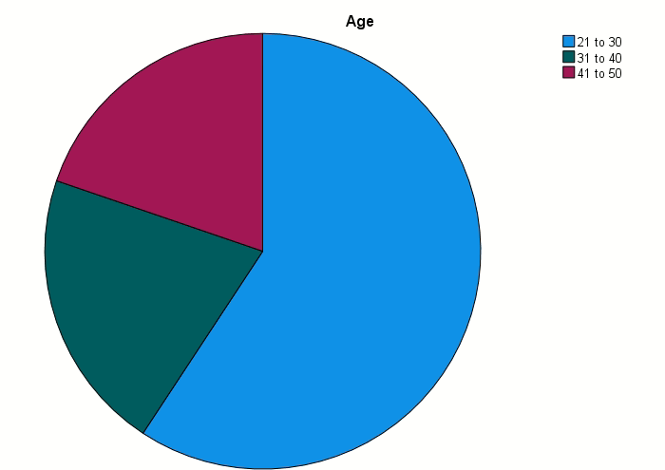

**Figure: Pie chart representation of age**

(Source: SPSS)

It represents the frequency of the age distribution of a specific sample group. It is analysed that the majority in age group is in the frequency between 21 to 30. This group represents 48 individuals compared to the whole group. The percentage that it represents is 59.3% of the valid responses. The age between 31 to 40 is the second largest contribution in the age group (So et al., 2020). It consists of 17 individuals as compared to all responses. The percentage that it represents is 21% of valid respondents. The age group between 41 to 50 represents the smallest group with 16 people. The percentage that this portion represents is 19,8% among the valid responses. The frequency of age is done by using the help of graphical representation. Pie chart is the graphical representation which is chosen for age frequency. It will bifurcate all the age groups in different colours so that it is easy to classify. The large segment which is the age group between 21 to 30 is represented with the colour of blue (Stoica and Edu, 2023). Age group between 31 to 40 is represented with the colour of purple. The small age group between 41 to 50 frequency is represented with the help of green colour. Frequency of the age group breakdown provides a clear indication that the sample is skewed towards younger individuals. It is done especially for those in their twenties which represents the largest section in the pie chart. It is evaluated that there is a decrease in the representation with increase in age. The pie chart shows that the significant portion of the sample is relatively by the young age group of. 31 to 40.

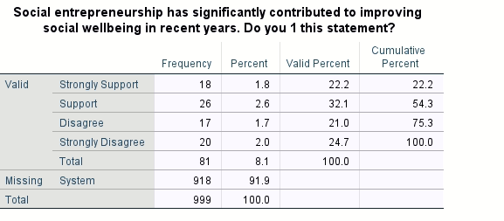

**Figure: Responses of social enterprise contribution for improvement in social wellbeing**

(Source: SPSS)

Figure 2 represents the responses related to the question of “Social entrepreneurship has significantly contributed to improving social wellbeing in recent years.” It consists of frequency which represents the number of responses in each section. It also consists of the percentage that the number represents as compared to all the responses (Borzaga et al., 2020). It is evaluated on the basis of four main c categories. The categories include Strong support, support, disagree, and strongly disagree. It consists of 81 valuable respondents among which 18 people strongly support this statement. The largest group has 26 individuals who simply support this statement. The percentage of the largest section is 32.1% compared to the overall responses. Both of these groups represent 54.3% of the responses which shows a positive impact on social wellbeing from social entrepreneurship. It was analysed that there were respondents who also disagree with this statement. 17 individuals who disagree with the statement represent 21% as compared to all of the responses. 20 individuals who strongly disagree with this statement represent 24.7% as compared to all the responses. This disagreement shows a sceptical review on the positive impact of social entrepreneurship for the improvement of social wellbeing. According to the table it is evaluated that half of the valid respondents hold a positive view of social entrepreneurship’s role in improving social well being. It was also seen that a minority section of the responses either disagrees or strongly disagrees about social entrepreneurship’s role in improving social well being.

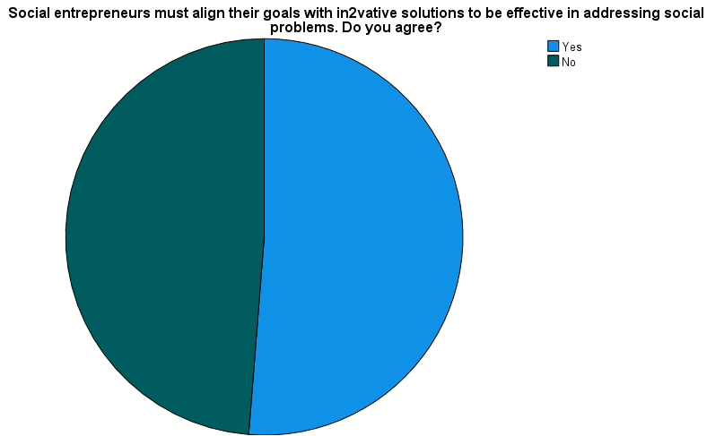

**Figure: Pie chart representation of social enterprise goal alinement**

(Source: SPSS)

The pie chart represents the response of the survey question related to "Social entrepreneurs must align their goals with innovative solutions to be effective in addressing social problems (Rouder et al., 2021). Do you agree?". It is evaluated that the survey consists of 81 responses from different individuals. 41 individuals agreed that social entrepreneurs must align their goals with innovative solutions to effectively address social issues. It represents 51.2% as compared to the total responses of this survey. It was also seen that there were people who disagreed with this statement. There were 39 respondents who disagreed with the whole statement. It represents 48.8% as compared to the total sum of the respondent. This data is represented with the help of a pie chart along with different colours representing different sections. It is estimated that the chart shows a nearly even split between the two groups. There is a slight majority favouring the option of "Yes". The perspectives of different people on whether innovation is essential for social entrepreneurs to solve societal problems is highlighted through this chart (Schnürer et al., 2020). The pie chart represents the response of the survey question related to "Social entrepreneurs must align their goals with innovative solutions to be effective in addressing social problems. Do you agree?". It points to a debate within the sector of agreement and disagreement. According to the response it is evaluated that many believe in the importance of innovation in a substantial group and remain sceptical for different approaches. According to the chart it is seen that the response of yes is represented with the colour of blue and No is represented with the colour of green. It is seen that there is no major difference between the responses of yes and no.

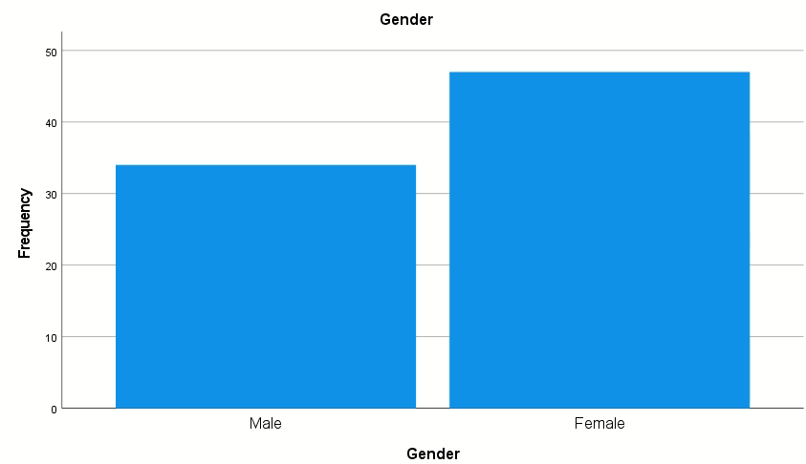

**Figure: Bar chart representation of gender**

(Source: SPSS)

The analysis presented in the gender distribution of respondents through 81 individuals. The size of the sample is 999 out of which 81 participants participated. It shows that there was a missing figure of respondents in the data which shows the shoes gap (van et al., 2021). According to the respondents 34 respondents were identified as male. It represents 42% among those who disclosed their gender in the responses. It is analysed that 47 respondents were identified as female amazon all the responses. The female gender represents 58% of those who answered the gender question. This data is best represented with the help graphical representation of bar. This data provides a visual representation of the gender breakdown of male and female. It is done with the help of the height of the bars which illustrates the number of respondents. Data of females is notably taller than the bar for males. This reflects the higher number of female respondents as compared to male respondents. Although due to the missing data of the respondent of 91.9% limits the generalizability of these findings. The missing data may affect the finding and results of the analysis. According to the data it is analysed that females constituted a slightly higher proportion than males (Bar, 2020). The missing figure of the gender highlights the need for further analysis for better understanding of the sample population.

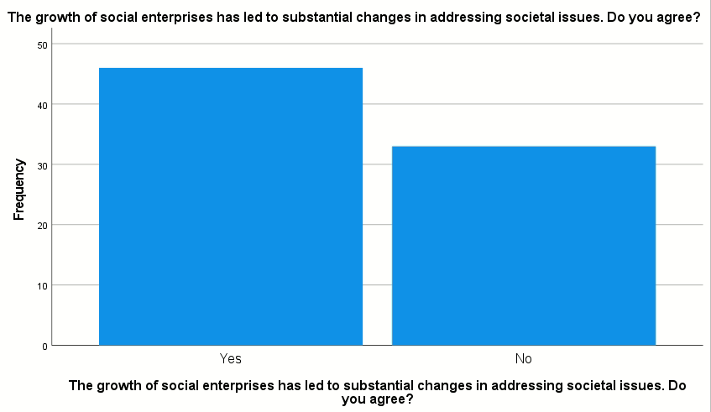

**Figure: Bar chart representation of growth of social enterprise**

(Source: SPSS)

The frequency table presents a breakdown of responses to the statement, "The growth of social enterprises has led to substantial changes in addressing societal issues." Out of the 999 total respondents, 79 provided valid answers, while 920 responses were missing, accounting for 92.1% of the total. Out of the valid responses, 46 participants, or 4.6% of the total, agreed with social enterprises having a substantial impact on societal issues. This group represents 58.2% of the valid responses. 33 respondents, or 3.3% of the total sample, disagreed on the role of social enterprise in addressing societal issues. This indicated scepticism related to the impact of social enterprises. This group accounts for 41.8% of the valid responses. The cumulative percentage shows that by the time all respondents who disagreed are accounted for, 100% of the valid responses. It has been indicated by the distribution that the majority of the respondents who have provided an answer, 58.2%, perceive that social enterprises have a positive impact on societal change. It is important to note that the high number of missing responses as indicated by the value of 920 suggests that a large portion of the sample made a choice of not responding to the question.

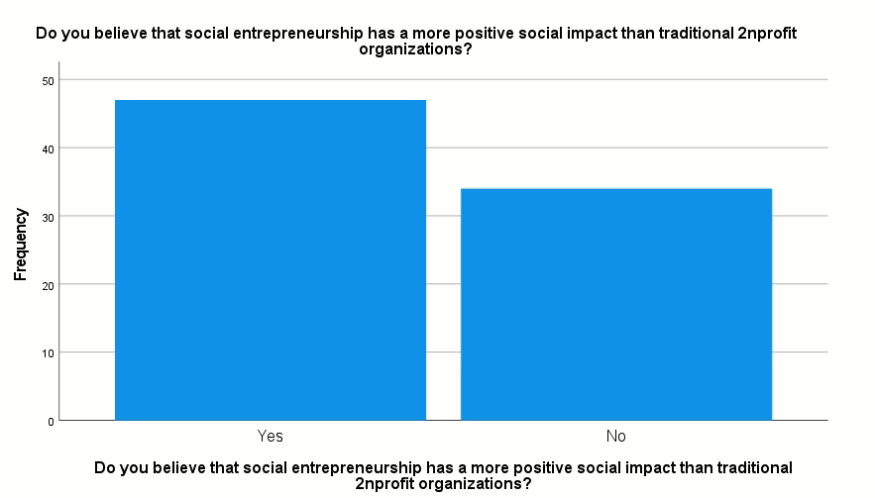

**Figure: Bar chart representation of social enterprise has more positive social impact**

(Source: SPSS)

The frequency table provides information on the views of the respondents on whether social entrepreneurship has a more positive social impact than traditional nonprofit organisations. Out of the total of 999 participants, only 81 (8.1%) gave valid responses, while 918 (91.9%) responses were missing or participants chose to not respond. Among the valid responses, 58% (47 respondents) believed that social entrepreneurship has a more significant positive impact with 42% (34 respondents) disagreeing with the positive impact of social entrepreneurship. This indicates that more respondents feel that social enterprises are more effective than traditional nonprofits in influencing social change. The cumulative percentage shows that by the time 58% of responses were counted, an approval was shown by all participants on the positive impact of social entrepreneurship. This indicates that a consensus was achieved on the responsibility of organisations in being more equipped for addressing the social challenges, particularly by the introduction of solutions and business models that can be innovative and sustainable. The portion of missing data that has been significantly denoted by 91.9% points out that there exists a gap in the knowledge related to social entrepreneurship which sheds light on the need of introducing campaigns that can raise awareness on social entrepreneurship.

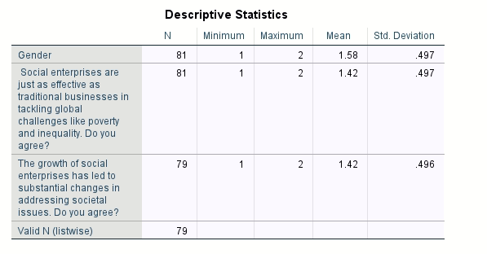

**Figure: Descriptive analysis**

(Source: SPSS)

Descriptive statistics can be used for the purpose of describing the characteristics of a dataset as it is a way of interpreting data (Murphy, 2021). The descriptive statistics represent the perceptions regarding the role of social enterprises. The mean value of 1.58 in case of gender (1 likely for males and 2 for females) denotes that there exists a slight male majority in the sample. In the case of the statement on "Social enterprises are just as effective as traditional businesses in tackling global challenges like poverty and inequality," the mean score is 1.42, with the standard deviation being 0.497. This means that the majority agrees (where 1 likely represents agreement). In the case of the statement "The growth of social enterprises has led to substantial changes in addressing societal issues," the mean score is again 1.42, with a standard deviation of 0.496. The sample size for this question was 79 which is slightly lower than the other questions. A positive perception on the role of social entrepreneurship in influencing social change has been revealed by these values. This indicates that sustainable development can be promoted in the process of addressing the global issues in an effective manner, which is specifically important for achieving the goals related to sustainability.

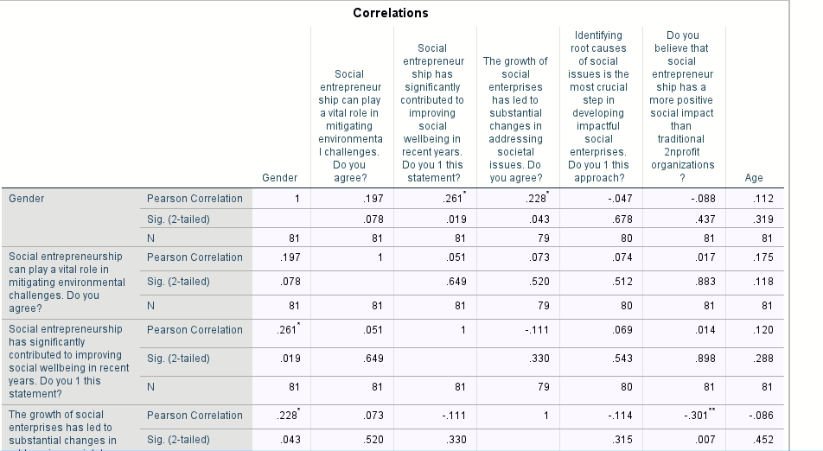

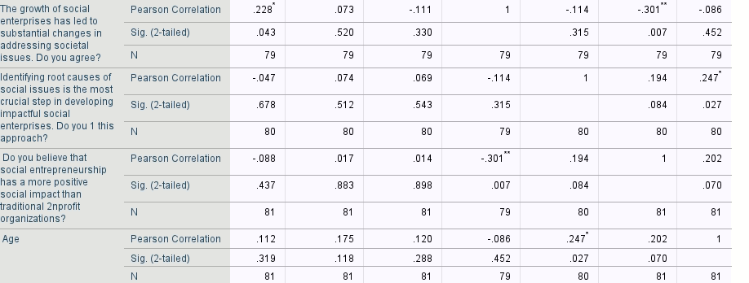

**Figure: Correlation**

(Source: SPSS)

The correlation matrix shows the relationships between the different aspects of social entrepreneurship and demographic variables such as gender and age with a focus on the different perceptions related to social change, environmental challenges, social wellbeing, and the development of enterprises that are impactful. The values of Pearson correlation and their significance (Sig. 2-tailed) have been discussed for each variable. Pearson Correlation can be applied to find the relations between the variables (Milovanović & Perišić, 2020). A correlation can be considered statistically significant if its “Sig. (2-tailed)” < 0.05 (Fiandini et al., 2024). In the case of gender, a positive correlation of 0.197 can be observed with the belief that social entrepreneurship assumes an important part in the mitigation of challenges related to the environment but the significance value of 0.078 suggests this correlation does not have much statistical significance. Gender shows a positive correlation of 0.261 with the view that social entrepreneurship has contributed to the improvement in social wellbeing, with a significance of 0.019, indicating a relationship that is statistically significant. Gender is not correlated with other variables to a significant extent, one such variable is social entrepreneurship that has led to substantial change in the societal as depicted by pearson correlation of 0.228, and Sig. value of 0.043. It is important to identify the root causes of social issues for impactful entrepreneurship as denoted by the pearson correlation of 0.047 and Sig. value of 0.678.

The perception that social entrepreneurship assumes an important part in the mitigation of environmental challenges is positively correlated with the belief that social entrepreneurship contributes to improving social wellbeing (0.051) and societal change (0.073), though these correlations are not statistically significant as represented by Sig. values of 0.649 and 0.520, respectively. It has a weaker negative correlation with identifying root causes as depicted by the correlation value of -0.047 and the belief that social entrepreneurship is more impactful than traditional nonprofits as represented by the value of 0.017. The belief that social entrepreneurship has contributed to improving social wellbeing shows no significant correlation with most variables, except for gender (0.261) and age (0.120), with gender being statistically significant. This belief has weak negative correlations with societal changes (-0.111) and the impact of traditional nonprofits (0.014), but these correlations are significant as represented by the Sig. values of 0.330 and 0.898, respectively. The perception that the growth of social enterprises has led to substantial changes in society has a positive correlation of 0.228 with gender. This is statistically significant as depicted by the Sig. 2-tailed value of 0.043. It negatively correlates with the belief that identification of the root causes of social issues is the most important step (-0.114) and that social entrepreneurship has a greater social impact than traditional nonprofits (-0.301, 0.007). The latter shows statistical significance as depicted by greater belief in the role of social enterprises in influencing societal change. In the case of the variable related to identification of root causes of social issues, there is no significant correlation with most variables, though it shows a weak positive correlation with age as represented by the values 0.247, 0.027. The belief that social entrepreneurship has a more positive social impact than traditional nonprofits shows weak correlations with most variables as depicted by a negative correlation of -0.301 with societal changes having a (Sig. 2-tailed) value of 0.007 that shows statistical significance. Gender is positively but weakly correlated with most variables like the belief in identifying root causes having Pearson correlation value of 0.247 and (Sig. 2-tailed) value of 0.027 and social wellbeing improvements (0.120).

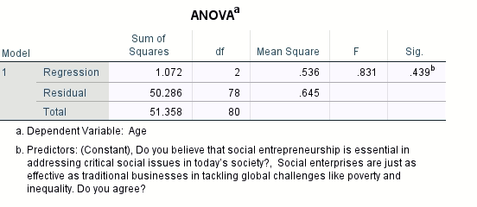

**Figure: Anova for regression**

(Source: SPSS)

The above Figure has represented an "ANOVA for regression" that provides an analysis of statistical data to determine the outcomes of a study. A tabular representation of numeric data has been retrieved through the use of "regression and residual" models. Apart from the column of models, there are other five columns namely the: "Sum of Squares, df, Mean Square, F, and Sig". The sum of squares helps in calculating the level of variability from the mean of data (Shrestha, 2021). Df is representative of the independent variables used for data analysis. Similarly, mean square, F value, and Sig. Represents the average, ratio, and difference of a given numerical dataset, respectively (Fouad et al., 2021). In this figure, the Sum of Squares for the regression model accounts for 1.072, df is 2, Mean Square accounts for .536, F value is .831, and Sig. represents a value of .439b. Similarly, for the residual model, the sum of squares is 50.286, and the value of df is 78. The other three columns do not show any numerical data. Thereafter, the total of the sum of squares and df has been calculated for the regression and residual models which show a numeric value of 51.358 and 80, respectively. This shows that the residual model indicates a higher level of variability as it has a greater numeric value than the regression model. The data for calculating the impact of social entrepreneurship has been evaluated using the ANOVA analysis to provide a vivid understanding of the complexities within social enterprises in maintaining sustainable development.

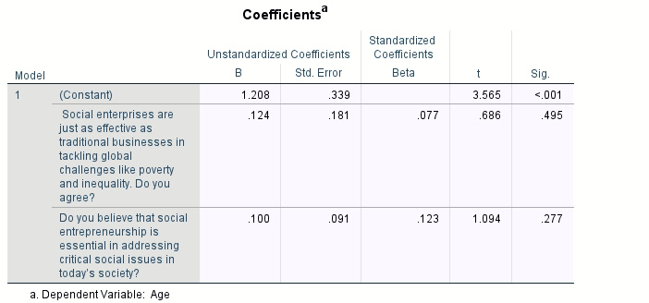

**Figure: Coefficients of regression**

(Source: SPSS)

The above Figure shows a tabular representation of the "coefficients of regression". This has been beneficial in providing a comparison between the social and traditional enterprises. Age is taken as a dependable variable. The coefficients are usually divided into "unstandardized and standardized" coefficients (Nieminen, 2022). The unstandardized coefficients are categorised into B and Std. Error while the standardized coefficients are subdivided into Beta, t, and Sig. The value of the constant for B is 1.208, for Std. Error it is .339, the value of t is 3.565, and the value of Sig. is < .001. Under the column of constant, two questions are asked about the study on social entrepreneurship and sustainable development. The first question is indicative of a comparison between social and traditional enterprises. This question is inclined towards retrieving information on the effectiveness of social enterprises in overcoming challenges such as poverty and inequality in comparison to traditional businesses. The second question is a continuation of the former and is inclined towards acquiring information regarding the strategic approach of social entrepreneurship in mitigating certain social issues. The value of B and Std. Error for the first question is .124 and .181, respectively, whereas the values of beta, t, and Sig. are .077, .686, and .495. The values for B and Std. Error in the second question accounts for .100 and .09, respectively. The values of beta, t, and Sg. for the second question are .123, 1.094, and .277. These values show a high level of growth and development of social enterprises depending on the responses of the participants.

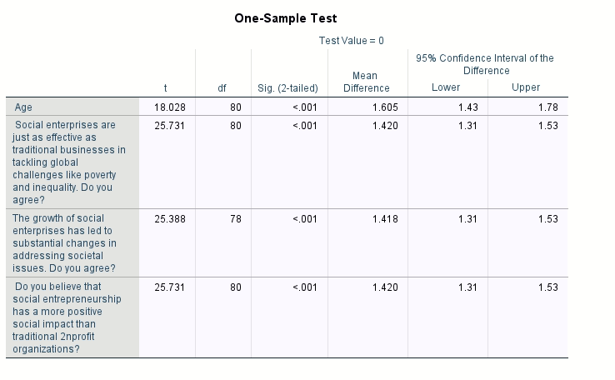

**Figure: One sample T test**

(Source: SPSS)

The above figure represents the one sample test of 81 participants of a survey on the topic based on - “an investigation into how social entrepreneurship affects social change and sustainable development”. This is a result of one sample t-test which was conducted with 81 participants to determine if the participant’s views prominently differ from the neutrality. The test evaluated opinions on the effect of social enterprises on society, the wider societal effect of social entrepreneurship, and the efficacy of social enterprises in comparison to regular firms. The test for age t=18.028,df=80,p <0.001 gave a mean difference of 1.605, exhibiting a vital deviation from neutrality (Canestrino et al., 2020). This finding demonstrates that the age dispersion of the sample is representative and offers a strong demographic basis for interpreting other findings. Through a mean difference of 1.420, the one-sample t-test for the efficiency of social business in tackling global concerns like poverty and inequality produced a prominent result “t = 25.731, df = 80, p < 0.001”. This view appears to be generally held among participants, as indicated by the confidence interval 1.31, 1.53, which emphasises a strong conviction in social businesses' capacity to promote significant social change and favourably impact responsible development initiatives.

A highly noteworthy result "t = 25.388, df = 78, p < 0.001" with a mean difference of 1.418 was obtained from the "one-sample t-test" used to evaluate participants' opinions on the influence of social enterprise growth on societal change. There is broad agreement among respondents that the development of social businesses significantly aids in resolving societal concerns, as seen by this positive mean difference. As per the view of Rosca et al., 2020, The participants' perception of social companies as accelerators for social progress is supported by the narrow confidence interval of 1.31, 1.53. According to this finding, social entrepreneurs are thought to be essential to promoting sustainable growth and bringing about significant social change. In the statement contrasting social entrepreneurship to traditional non-profits, the t-test t=25.731, df=80, p<0.001, mean difference=1.420 provides that users believe social entrepreneurship has a more positive social effect. In general, the findings point to a positive perception of social entrepreneurship's influence on equitable growth and social transformation. The overwhelmingly positive answers demonstrate how social companies are seen as more productive and contributing to society than standard corporations.

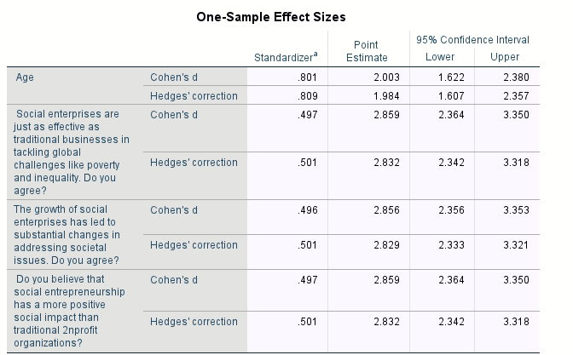

**Figure: One sample effect size**

(Source: SPSS)

The above Figure represents a "one sample effect size" of the data collected for analysing the effects of "social entrepreneurship on social change and sustainable development". The application of Cohen's and Hedges' correction metric is essential to derive an effective sample effect size of the data. There are a total of three responsive questions asked to understand whether the effects of social entrepreneurship are positive or negative. The values have been distributed among "standardizer, point estimate, and 95% confidence level". The confidence level has been further categorised as lower and upper. The values for Cohen's d correction metric have been distributed among these standards of measurement. The values are .801, 2.003,1.622, and 2.380 for Cohen's d correction metric. The constant values for Hedges' correction metric are .809, 1.984, 1.607, and 2.357. The values for the first question by Cohen's d and Hedges' correction metric are .497, 2.859, 2.364, 3.350 and .501, 2.2832, 2.364, 3.318, respectively. The values for the second question, calculated through Cohen's d and Hedges' correction metric are .496, 2.856, 2.356, 3.353 and .501, 2.829, 2.333, 3.321, respectively. Similarly, the values for the third question are distributed as .497, 2.859, 2.364, 3.350 and .501, 2.832, 2.342, 3.318 by Cohen's d and Hedges' model respectively. The values generated using the metric of Cohen's d and Hedges' correction have been beneficial in acquiring and calculating an effective sample effect size. This has helped in vividly understanding the effectiveness of social entrepreneurship and its relevant consequences on sustainable development.

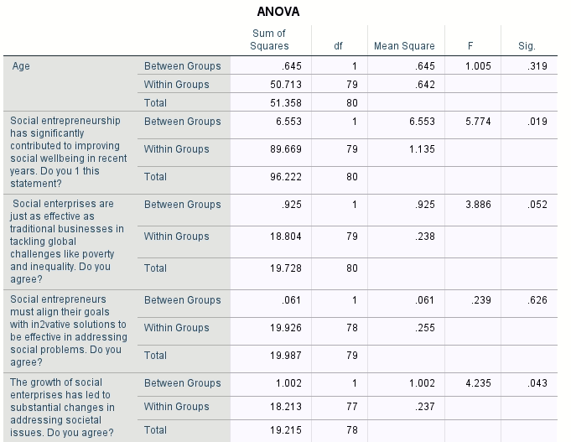

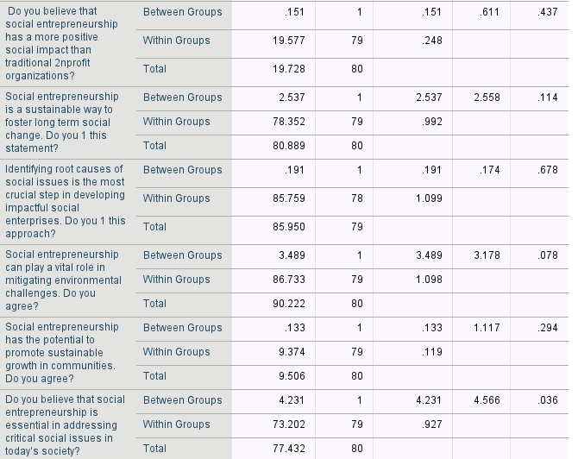

**Figure: One way anova**

(Source: SPSS)

Every variable and its importance is evaluated in light of participant responses about the function of social business to examine the findings of the ANOVA test for this study on the influence of social entrepreneurship on societal changes and sustainable growth. By comparing responses across groups "such as age groups" or points of view), the ANOVA test enables us to ascertain if the mean replies of these groups differ substantially, therefore illuminating the variety of perspectives. The findings highlight several significant areas wherein respondent views differ, especially with regard to the perceived value of social entrepreneurship in enhancing welfare and tackling pressing problems that can be viewed in the study by Gupta et al., 2020. Participants mostly concur on the benefits of social entrepreneurship and its potential as a long-term force for shifting despite the fact that age does not seem to influence opinions. Although opinions are usually positive, there is still variation in respondents' prioritization of the function and efficacy of social entrepreneurship in society, according to significant results on several items. For Age - the variable seems to be a non-significant outcome p<0.05, deviating no meaningful difference in the responses of age. This suggests that perceptions are constant across age groups since age does not appear to have an influence on participants' overall opinions on social entrepreneurship in this survey.

This variable indicates that there are variations in answers across groups about whether social entrepreneurship has enhanced social welfare, with a significant result (p < 0.05). The idea that many participants saw social entrepreneurship as a factor in promoting social welfare is supported by the positive F-value. This result is around the threshold, suggesting a possible difference in replies on the efficacy of social enterprises vs standard firms, even if it is marginally non-significant "p = 0.052". Despite no discernible group differences, this finding is non-significant p > 0.05, suggesting that participants generally agree on this point. With little variance among replies, it indicates a common perception that the expansion of social enterprises is influencing society's developments. As per the study by Sahasranamam & Nandakumar, (2020), The non-significant p-value "p > 0.05" suggests that opinions on whether social entrepreneurship has a bigger social impact than traditional NGOs do not differ significantly between groups. This non-significant result p > 0.05 indicates that individuals had a similar opinion with little variation. The findings suggest that social entrepreneurship is widely regarded as a viable strategy for promoting long-term change. In the last variable- This important result (p < 0.05) indicates that participants' perceptions of the importance of social entrepreneurship in tackling today's urgent social concerns vary.

## 4.3 Findings

**Ideas of social entrepreneurship**

According to Canestrino et al. (2020), the idea of social entrepreneurship (SE) has mainly attracted the attention of both practitioners and academics. It has been shown by an increasing body of theoretical literature and also by the growing of new scientific and non-scientific communities. The concept of social entrepreneurship outlines the existing overlap among various levels of analysis, such as individual studies (micro level), process and organisational studies (meso level), and wider studies of the context of political, economic, and social (macro level). The growing recognition of SE's contribution to societal and economic well-being is generating scholars’ interest in the procedures and their resulting effects on the creation of social value. “*Defining SE is not easy, mainly because of the lack of homogeneity in the available definitions about the issue, as well as the flourishing perspectives used to approach the phenomenon*” (Canestrino et al., 2020, p. 2). It has been suggested that SE is characterised by an absence of theoretical boundaries, and is faced with competing conceptual frameworks and definitions, literature gaps, and limited empirical data. In addition, SE is critical to detail due to the complexity of describing its two integral concepts including social outreach and entrepreneurship.

On the other hand, as per the view of Gupta et al. (2020), SE has evolved as a popular research area of great significance for researchers and organisations. It works as a catalyst for social change and SE do not directly expect financial advantages from their social projects. An analysis of existing literature reviews on social entrepreneurship discloses a dearth of studies categorising the existing SE literature into numerous research themes and introducing popular as well as less popular research themes. SE varied from conventional entrepreneurship in its principal mission of generating social value despite creating private economic achievements. Social entrepreneurship combines the pursuit of public social products with the market-aligned techniques and tools of for-profit firms. Therefore, SE essentially performs at the boundaries of the conventional philosophies of organisations. Simply, SE may be regarded as a novel activity that is designed to originate producer surplus by creating positive externalities or decreasing negative externalities. This happens through the incorporation of the concentration of entrepreneurship as well as social constructs.

According to the corelation table, it has been analysesd the relationships between the different aspects of social entrepreneurship and demographic variables including gender and age with a focus on the different perceptions related to social change, environmental challenges, social well-being, and the development of enterprises that are impactful. SE has contributed to improving social well-being and shows no significant correlation with most variables, except for gender (0.261) and age (0.120), with gender being statistically significant (Urban, 2020). The non-significant p-value “p > 0.05” suggests that SE has a higher social impact compared to traditional NGOs that do not significantly differ between groups.

As opposed to the above article, Sahasranamam & Nandakumar, (2020), pointed out that social entrepreneurship addresses social requirements that are not completely met by commercial enterprises and aids social change via innovative approaches. It originates social value via market-aligned strategies and merges social attributes and the mission of the commercial business, satisfying unmet demands. Social entrepreneurship also pursues opportunities in a creative manner to address social requirements and catalyse social change. Besides, Tinh et al.(2023) suggested that SE can be compared with commercial enterprises in the settings of functional and indicative viewpoints. Social entrepreneurship can be utilised to leverage new business opportunities because of the trend of sustainable agricultural improvement. SE created a circular economy of agriculture with the aim of reducing difficulties from climate change with the usage of renewable energy and with the restriction of natural resources.

**Role of social entrepreneurship in addressing social and environmental issues**

As per the view of Ahmad & Bajwa, (2023), social entrepreneurship provides innovative solutions regarding social problems and deploys the capacities, resources, and ideas for sustainable social transformation. SE practically originates social and economic value by addressing critical social issues, and it accompanies the role of the public and private sectors. Social entrepreneurship offers a geographic setting for the creation of social ventures, the underlying companies' structures and dynamics, and how these typologies estimate the social effect, deploy resources and bring about sustainable social change. These eventually contribute to socio-economic improvement. Social entrepreneurship is a subsidiary domain of entrepreneurship that sustains a bidirectional relationship with the development of socio-economic. “*Social entrepreneurship is one of the leading determinants of economic development*” (Ahmad & Bajwa, 2023, p. 3). It has been interpreted that economically advanced countries with a democratic regime, robust property rights, and a free market system are more feasible for social entrepreneurship and innovation. SE addresses the social issues of society including literacy, public health, poverty, crises of energy and water, human and labor rights, social inequality, environmental issues and unemployment. Social entrepreneurship indirectly and directly leads to socio-economic improvement by solving social challenges. SE promotes community building and encourages a culture of innovative problem-solving in the community that eases economic advancement.

Based on the above-provided bar graph on the role of social entrepreneurship, it has been interpreted that most of the respondents do not properly respond about the positive social impact of social entrepreneurship. On the other hand, only 81 (8.1%) respondents gave valid responses which has been considered that social entrepreneurship offers different types of facilities that influence a more positive social impact in comparison to conventional non-profit companies. However, only 58% (47 respondents) among the valid responses, believed that the idea of social entrepreneurship provides societal and economic well-being which has a positive effect on the creation of value. Besides, 42% (34 respondents) disagreed with this statement which indicated that they do not feel SE is helpful in the settings of increasing positive social impact (García-Jurado et al., 2021). This information considered that a concurrence percentage was achieved on the responsibility of organisations in being more equipped for addressing the social challenges, particularly by the presenting of solutions and business models that can be innovative and sustainable.

In contrast to the above article, according to Méndez-Picazo et al. (2021), SE has a positive impact on sustainable development via its associated activities, assisting job creation. Therefore, growing the collection demand of the economy will encourage economic advancement. Social entrepreneurship plays a significant role in improving sustainable development by achieving the objectives of this and environmental responsibilities introduce a better business opportunity and enable entrepreneurs to adopt new market demands as well as enhance their image with key stakeholders, and separate their products. Particularly, SE has a positive relationship with sustainable development because it determines the significant factors that influence sustainable activities. SE is a new factor to examine in changing the objective of economic growth for sustainable improvement to avoid compromising the condition of future generations via recent policies designed to gain present-day well-being.

In order to justify the mentioned information regarding the concept of SE, it has been analysed that the role of social entrepreneurship exhibits a positive perception in influencing social change that has been revealed by the mean values with standard deviation. This type of descriptive statistics demonstrated that sustainable development can be promoted in the procedures of addressing worldwide issues in an effective manner, which is specifically important for achieving the goals related to sustainability.

On the other hand, as stated by Shahid et al. (2023), sustainable entrepreneurship helps to solve environmental degradation and inequality which is supported to achieve increasing recognition from practitioners, scholars, and policymakers. Therefore, sustainable entrepreneurship stresses the conceptual distinction from conventional entrepreneurship, additional obstacles to sustainable businesses, and the potential of triple-bottom-line objectives. Sustainable entrepreneurship has been connected with the concepts of social entrepreneurship and ecopreneurship for their concentration on preserving the natural environment and originating social value. SE based on frugal innovation contributes to numerous social outcomes, including improved quality of life, female empowerment, and access to affordable healthcare facilities for low-income customers. It also provides environmental outcomes, like production techniques and sustainable products. Sustainable entrepreneurship operates new markets in advancing countries and cultivates inclusive growth. It enables organisations to make a profit and lead to solving societal issues simultaneously. SE has to originate environmental and social benefits along with the conventional aspect of economic rents.

**Social entrepreneurship in social changes**

According to Pareja-Cano et al. (2023), social entrepreneurship is differentiated by its particular

intention to bring about social change. The empowerment-based model leads to explanations about the procedures of social change inherent in the phenomenon of social entrepreneurship. The findings of this article show that social entrepreneurship efficiently mitigates the problems related to beneficiaries to influence the social change process. However, existing research demonstrated that power utilising could offer an encompassing explanation that shows how social entrepreneurship proceeds social change. Empowerment could be a valid interference that builds to an explanation regarding the relationship between the achievement of social goals and entrepreneurial practices. Empowerment to separate social entrepreneurship from the context of philanthropic ventures although SE wants to change power relations and influence beneficiaries. The formal goal of social entrepreneurship is that it attends power to its intended targets. Simply, SE has been depicted as ‘emancipatory’. Social entrepreneurship offers women resources which make sure that they balance themselves and foster self-beliefs, with the potential aim of conceptualising the fundamental social change process. In addition, This article considered five entrepreneurial practices that contribute to a greater power of decision-making of disenfranchised women over their life options and provides multicausal, multidimensional, and contextually-grounded principles to describe how these practices influence intended beneficiaries and construct the gender gap.

According to the mentioned tables in the result section, it has been reviewed that the disagreement of the participant’s responses shows a doubtful review of the positive impact of social entrepreneurship on the improvement of social well-being. It has been implemented that half of the valid respondents hold a positive view of social entrepreneurship’s role in improving social well-being. Apart from that, a minority section of the responses was also seen to either include disagreement or strong disagreement about social entrepreneurship’s role in improving social well-being. Besides, social entrepreneurship has been essential in order to promote sustainable growth and bringing about significant social change according to the findings of the t-test t=25.731, df=80, p<0.001, mean difference=1.420 (Gupta et al., 2020). In comparison to the context of social change between SE to traditional non-profit organisations, users believe that social entrepreneurship has a more positive social effect. Particularly, positive responses considered that companies are seen as more productive and contributing to social change than standard corporations.

According to Torres & Augusto (2020), the main goal of the government should be the nation's well-being and entrepreneurship, not well-being. In the era of rapid digitalization, the concerned policymakers are inclined toward entrepreneur skill sets. These skills are an essential feature for expanding the economy and boosting financial support in the business environment. Individuals involved in the field of entrepreneurship are often observed conducting research and experiments in order to create innovative ideas. Collection of information and indulging in result-oriented activities are the common characteristics of entrepreneurship that are present in the business environment. However, it is important to mention the reaction of finding it. The present study moderately agrees in highlighting the essentiality of social entrepreneurship in social change. 18 participants strongly agreed along with 26 that just supported the statement, while 17 of them strongly disagreed. Based on the result of this study, it is obvious that businessmen have a great effect on social change. The incorporation of a financially philanthropic society can build individuals who display extraordinary vision and ambition.

According to Chatterjee et al. (2021), social change involves a diversified process in changing the dynamic of structure, pattern and trends present in the societal domain. Social entrepreneurship can act as constructive agents in identifying societal issues and transforming them. However, transformation of the problem can be a difficult task without the implementation of social entrepreneurship characteristics. Pioneering creativity that is void of any personal biases can be initiated to alter the entire structure of society. The replacement of traditional approaches to modern digital tasks is the key to bringing valuable results to every individual within society. Similarly, the present research that has been conducted in measuring the worth of entrepreneurship influencing social changes supports the view of the author significantly. In the study, it has been propounded that social entrepreneurship contributes to addressing inequalities present within society. The primary survey conducted in the study significantly inclined toward the view that social entrepreneurship positively impacts non-profitable organisations. Hence it can be concluded that the gradual rise in addressing societal issues while implementing innovative ideas can create more goal-oriented individuals, organisations and businesses. However, it is important to mention that the race of social entrepreneurship can divert individuals from self-upliftment to social upliftment. This phenomenon can negatively impact the overall well-being of society as societal enhancement refers to the contribution of all the individuals constituting it. Therefore, it is essential to maintain a balance between the two. The totality of positive outcomes of society depends upon the individual that is shaping it for a better future.

**Role of Social entrepreneurship to lead sustainable growth**

As per the view of Al-Qudah et al. (2022), in sustainable development, social entrepreneurship plays a significant role in terms of creating value, capturing and delivering in the nature of the relationship among the sustainable development and its advanced variables as well as how these variables can provide an impact on sustainable development. The nexus of sustainable development and social entrepreneurship is specifically relevant that concentrates on the quality of life which requires that organisations reconcile sustainability choices with social life dimensions. SE and innovations have been recognised as key factors to defuse sustainability requirements. This article provides a stage of discussion in which some of the many ways are explored that emphasise innovations, social entrepreneurship, and institutional aspects. These are utilised in connection with sustainable development. Both sustainable development and social entrepreneurship are considered potential solutions to guarantee the future development of the entire society. The concept of sustainable development has been increased to address the contribution of entrepreneurial activities, approached as an all-inclusive idea, to mitigate societal problems. Sustainable development acquires some primary features such as social responsibility, progressiveness, innovativeness, competitiveness, knowledge creation and usage, dynamism and looking for business advantages that create social value.

According to Bľanda & Urbančíková (2020), one of the effective tools for social development is social entrepreneurship. Towards the 20th century, countries around the world have shown substantial efforts mitigating poetry, low literacy and social equality. Complementary advantages pertaining to social, environmental and economic can be fulfilled by applying social revolutionary ideas. The effort of organisations in building a nation that comes with problem-solving solutions has tremendously influenced the way people work and think. Similarly, results that have been derived from the answers of 81 participants agree that social entrepreneurship leads to sustainable growth within society. It has been observed that the rise in alertness among entrepreneurs has assisted in channelling their efforts to different sectors of society. The collective results of which is a diminishment of poverty and an upliftment of the literacy rate. Strategic operations involved in the process of building a robust social business not only have increased business but also influence the young mind present in the society.

## 4.4 Summary

At the end of this chapter, it can be concluded that The findings of this study on how social entrepreneurship contributes to social change and sustainable growth. This section explores opinions on various topics related to social entrepreneurship, including how social entrepreneurship solves social problems, how it contributes to long-term sustainability, and how social entrepreneurship is perceived in relation to purpose-driven businesses and organisations and traditional nonprofits. Data were collected using a questionnaire and responses of 81 participants were analysed for trends and statistical significance using one-sample t-tests, regression tests, frequency tests, coefficient tests, and ANOVA tests. Following an examination of age as a demographic factor, the section delves into participants' viewpoints on the specific advantages of social entrepreneurship. This understanding forms the foundation for what comes next. These findings illustrate how social entrepreneurship is perceived as an effective and successful approach to driving societal change by showcasing both areas of consensus and divergence in this study.

# References

Ahmad, S., & Bajwa, I. A. (2023). The role of social entrepreneurship in socio-economic development: a meta-analysis of the nascent field. *Journal of Entrepreneurship in Emerging Economies*, *15*(1), 133-157. <https://www.researchgate.net/profile/Shabir-Ahmad-3/publication/356172628_The_role_of_social_entrepreneurship_in_socio-economic_development_a_meta-analysis_of_the_nascent_field/links/61a68a6db4bbff76e27b2d04/The-role-of-social-entrepreneurship-in-socio-economic-development-a-meta-analysis-of-the-nascent-field.pdf>

Alharahsheh, H. H., & Pius, A. (2020). A review of key paradigms: Positivism VS interpretivism. *Global Academic Journal of Humanities and Social Sciences*, *2*(3), 39-43.<https://gajrc.com/media/articles/GAJHSS_23_39-43_VMGJbOK.pdf>

Almquist, Y. B., Kvart, S., & Brännström, L. (2020). A practical guide to quantitative methods with SPSS.<https://su.figshare.com/articles/preprint/A_practical_guide_to_quantitative_methods_with_SPSS/10321829/2/files/22477367.pdf>

Al-Qudah, A. A., Al-Okaily, M., & Alqudah, H. (2022). The relationship between social entrepreneurship and sustainable development from economic growth perspective: 15 ‘RCEP’countries. *Journal of Sustainable Finance & Investment*, *12*(1), 44-61. <https://www.researchgate.net/profile/Manaf-Al-Okaily/publication/349304854_The_relationship_between_social_entrepreneurship_and_sustainable_development_from_economic_growth_perspective_15_'RCEP'_countries/links/602ee1784585158939b47207/The-relationship-between-social-entrepreneurship-and-sustainable-development-from-economic-growth-perspective-15-RCEP-countries.pdf>

Anand, A., Argade, P., Barkemeyer, R., & Salignac, F. (2021). Trends and patterns in sustainable entrepreneurship research: A bibliometric review and research agenda. *Journal of Business Venturing*, *36*(3), 106092.<https://www.sciencedirect.com/science/article/am/pii/S0883902621000021>

Bar-Lev, S., & Beimel, D. (2020). Numbers, graphs and words–do we really understand the lab test results accessible via the patient portals?. Israel Journal of Health Policy Research, 9, 1-14. <https://link.springer.com/content/pdf/10.1186/s13584-020-00415-z.pdf>

Bľanda, J., & Urbančíková, N. (2020). Social Entrepreneurship as a Tool of Sustainable Development. Quality Innovation Prosperity, 24(3), 21-36. <https://www.qip-journal.eu/index.php/QIP/article/download/1463/1221>

Borzaga, C., Galera, G., Franchini, B., Chiomento, S., Nogales, R., & Carini, C. (2020). Social enterprises and their ecosystems in Europe. <https://www.bollettinoadapt.it/wp-content/uploads/2020/04/KE0220042ENN.en_.pdf>

Canestrino, R., Ćwiklicki, M., Magliocca, P., & Pawełek, B. (2020). Understanding social entrepreneurship: A cultural perspective in business research. *Journal of Business Research*, *110*, 132-143.<https://e-tarjome.com/storage/panel/fileuploads/2020-01-29/1580296616_E14240-e-tarjome.pdf>

Canestrino, R., Ćwiklicki, M., Magliocca, P., & Pawełek, B. (2020). Understanding social entrepreneurship: A cultural perspective in business research. *Journal of Business Research*, *110*, 132-143. <https://doi.org/10.1016/j.jbusres.2020.01.006>

Chatterjee, I., Cornelissen, J., & Wincent, J. (2021). Social entrepreneurship and values work: The role of practices in shaping values and negotiating change. Journal of Business Venturing, 36(1), 106064.<https://www.sciencedirect.com/science/article/pii/S0883902620306728>

Davey, M. G., O’Donnell, J. P., Maher, E., McMenamin, C., McAnena, P. F., Kerin, M. J., ... & Lowery, A. J. (2022). General data protection regulations (2018) and clinical research: perspectives of patients and doctors in an Irish university teaching hospital. Irish Journal of Medical Science (1971-), 1-7. <https://link.springer.com/content/pdf/10.1007/s11845-021-02789-8.pdf>

Fiandini, M., Nandiyanto, A. B. D., Al Husaeni, D. F., Al Husaeni, D. N., & Mushiban, M. (2024). How to calculate statistics for significant difference test using SPSS: Understanding students comprehension on the concept of steam engines as power plant. Indonesian Journal of Science and Technology, 9(1), 45-108. https://ejournal.kjpupi.id/index.php/ijost/article/view/348

Fouad, K. M., Ismail, M. M., Azar, A. T., & Arafa, M. M. (2021). Advanced methods for missing values imputation based on similarity learning. *PeerJ Computer Science*, *7*, e619. DOI 10.7717/peerj-cs.619

García-Jurado, A., Pérez-Barea, J. J., & Nova, R. J. (2021). A new approach to social entrepreneurship: A systematic review and meta-analysis. *Sustainability*, *13*(5), 2754. <https://www.mdpi.com/2071-1050/13/5/2754/pdf>

Gupta, P., Chauhan, S., Paul, J., & Jaiswal, M. P. (2020). Social entrepreneurship research: A review and future research agenda. *Journal of business research*, *113*, 209-229. <https://www.sciencedirect.com/science/article/am/pii/S0148296320301983>

Gupta, P., Chauhan, S., Paul, J., & Jaiswal, M. P. (2020). Social entrepreneurship research: A review and future research agenda. *Journal of business research*, *113*, 209-229.<https://www.sciencedirect.com/science/article/am/pii/S0148296320301983>

Gupta, P., Chauhan, S., Paul, J., & Jaiswal, M. P. (2020). Social entrepreneurship research: A review and future research agenda. Journal of business research, 113, 209-229. <https://www.sciencedirect.com/science/article/am/pii/S0148296320301983>

<https://nrl.northumbria.ac.uk/id/eprint/45308/1/mixed%20methods%20final%20version.pdf>

Husband, G. (2020). Ethical data collection and recognizing the impact of semi-structured interviews on research respondents. Education Sciences, 10(8), 206. <https://www.mdpi.com/2227-7102/10/8/206/pdf>

Kruse, P., Chipeta, E. M., & Venter, R. (2024). Do good and measure well!–Examining the validity of two positive social change measurements in South African social enterprises. *Journal of Entrepreneurship in Emerging Economies*, *16*(5), 1298-1318.<https://www.emerald.com/insight/content/doi/10.1108/JEEE-10-2022-0325/full/pdf>

Lobe, B., Morgan, D., & Hoffman, K. A. (2020). Qualitative data collection in an era of social distancing. International journal of qualitative methods, 19, 1609406920937875. <https://journals.sagepub.com/doi/pdf/10.1177/1609406920937875?%5D>

Méndez-Picazo, M. T., Galindo-Martín, M. A., & Castaño-Martínez, M. S. (2021). Effects of sociocultural and economic factors on social entrepreneurship and sustainable development. *Journal of Innovation & Knowledge*, *6*(2), 69-77. <https://www.sciencedirect.com/science/article/pii/S2444569X20300251>

Milovanović, M., & Perišić, J. (2020). Advantages and limitations of using SPSS in teaching statistics. MEFkon 2020 INNOVATION AS AN INITIATOR OF THE DEVELOPMENT “INNOVATIONS IN THE FUNCTION OF DEVELOPMENT”, 274.https://www.researchgate.net/profile/Dusan-Rajic-2/publication/346573316_Application_of_LT-Contradiction_Matrix_in_Innovation_Development_Innovation_as_an_Initiator_of_the_Development_pp_329-346_Belgrade_December_3rd_2020/links/5fc7da11a6fdcc697bd3846a/Application-of-LT-Contradiction-Matrix-in-Innovation-Development-Innovation-as-an-Initiator-of-the-Development-pp-329-346-Belgrade-December-3rd-2020.pdf#page=291

Murillo-Luna, J. L., García-Uceda, E., & Asín-Lafuente, J. (2021). Obstacles to social entrepreneurship. In *Social Entrepreneurship* (Vol. 5, pp. 195-216). Emerald Publishing Limited.<https://www.researchgate.net/profile/Jesus-Asin/publication/356505058_Obstacles_to_Social_Entrepreneurship/links/61ea6b8fdafcdb25fd3e36b1/Obstacles-to-Social-Entrepreneurship.pdf>

Murphy, K. R. (2021). In praise of Table 1: The importance of making better use of descriptive statistics. Industrial and Organizational Psychology, 14(4), 461-477.<https://www.cambridge.org/core/journals/industrial-and-organizational-psychology/article/in-praise-of-table-1-the-importance-of-making-better-use-of-descriptive-statistics/F11F114F1B5E26AACF8F1AF3C36F1EDE>

Nieminen, P. (2022). Application of standardized regression coefficient in meta-analysis. *BioMedInformatics*, *2*(3), 434-458.<https://doi.org/10.3390/biomedinformatics2030028>

Pareja-Cano, B., Valor, C., & Benito, A. (2023). How social enterprises nurture empowerment: a grounded theoretical model of social change. *Journal of Social Entrepreneurship*, *14*(1), 29-49.<https://repositorio.comillas.edu/xmlui/bitstream/handle/11531/67846/How%20Social%20Enterprises%20Nurture%20Empowerment%20A%20Grounded%20Theoretical%20Model%20of%20Social%20Change.pdf?sequence=1>

Park, Y. S., Konge, L., & Artino Jr, A. R. (2020). The positivism paradigm of research. *Academic medicine*, *95*(5), 690-694. <https://journals.lww.com/academicmedicine/fulltext/2020/05000/the_positivism_paradigm_of_r%20esearch.16.aspx/%22>

Rocha-Silva, T., Nogueira, C., & Rodrigues, L. (2024). Passive data collection on Reddit: A practical approach. *Research Ethics*, *20*(3), 453-470. https://journals.sagepub.com/doi/pdf/10.1177/17470161231210542

Rosca, E., Agarwal, N., & Brem, A. (2020). Women entrepreneurs as agents of change: A comparative analysis of social entrepreneurship processes in emerging markets. Technological forecasting and social change, 157, 120067. <https://doi.org/10.1016/j.techfore.2020.120067>

Rouder, J., Saucier, O., Kinder, R., & Jans, M. (2021). What to do with all those open-ended responses? Data visualization techniques for survey researchers. Survey Practice. <https://www.surveypractice.org/article/25699-what-to-do-with-all-those-open-ended-responses-data-visualization-techniques-for-survey-researchers>

Sahasranamam, S., & Nandakumar, M. K. (2020). Individual capital and social entrepreneurship: Role of formal institutions. *Journal of Business Research*, *107*, 104-117. <https://strathprints.strath.ac.uk/65448/1/Sahasranamam_Nandakumar_JBR_2018_Individual_capital_and_social_entrepreneurship_role_of_formal_institutions.pdf>

Sahasranamam, S., & Nandakumar, M. K. (2020). Individual capital and social entrepreneurship: Role of formal institutions. *Journal of Business Research*, *107*, 104-117. <https://strathprints.strath.ac.uk/65448/1/Sahasranamam_Nandakumar_JBR_2018_Individual_capital_and_social_entrepreneurship_role_of_formal_institutions.pdf>

Sałach-Dróżdż, K. Wealth inequality, income inequality, and subjective well-being: A cross-country study. *International Journal of Management and Economics*. <https://doi.org/10.2478/ijme-2024-001>

Schnürer, R., Ritzi, M., Çöltekin, A., & Sieber, R. (2020). An empirical evaluation of three-dimensional pie charts with individually extruded sectors in a geovisualization context. Information Visualization, 19(3), 183-206. <http://coltekin.net/arzu/publications/schnuerer_etal_2020.pdf>

Shahid, M. S., Hossain, M., Shahid, S., & Anwar, T. (2023). Frugal innovation as a source of sustainable entrepreneurship to tackle social and environmental challenges. *Journal of Cleaner Production*, *406*, 137050. <https://www.sciencedirect.com/science/article/pii/S0959652623012088>

Shrestha, N. (2021). Factor analysis as a tool for survey analysis. *American journal of Applied Mathematics and statistics*, *9*(1), 4-11.DOI:10.12691/ajams-9-1-2

So, H. Y., Oz, U. E., Griffith, L., Kirkland, S., Ma, J., Raina, P., ... & Wu, C. (2020). Modelling Complex Survey Data Using R, SAS, SPSS and Stata: A Comparison Using CLSA Datasets. arXiv preprint arXiv:2010.09879. <https://www.academia.edu/download/105974790/2010.09879v1.pdf>

Stoica, V.M. and Edu, T., 2023. Researching the Behavioral Elements of Online Video Game Players. A Detailed Analysis Using SPSS. Part III: Analysis of Video Game Users’ Behavior in Romania. Holistic Marketing Management Journal, 13(1), pp.12-25. <http://holisticmarketingmanagement.ro/RePEc/hmm/v13i1/2.pdf>

Strijker, D., Bosworth, G., & Bouter, G. (2020). Research methods in rural studies: Qualitative, quantitative and mixed methods. Journal of Rural Studies, 78, 262-270.

Taherdoost, H. (2021). Data collection methods and tools for research; a step-by-step guide to choose data collection technique for academic and business research projects. *International Journal of Academic Research in Management (IJARM)*, *10*(1), 10-38. <https://hal.science/hal-03741847/document>

Taherdoost, H. (2021). Data collection methods and tools for research; a step-by-step guide to choose data collection technique for academic and business research projects. International Journal of Academic Research in Management (IJARM), 10(1), 10-38.<https://hal.science/hal-03741847/document>

Taris, T.W., Kessler, S.R. and Kelloway, E.K., 2021. Strategies addressing the limitations of cross-sectional designs in occupational health psychology: What they are good for (and what not). *Work & Stress*, *35*(1), pp.1-5. DOI: 10.1080/02678373.2021.1888561

Tinh, N. H., Tien, N. H., Trang, N. T. T., & Van Trai, D. (2023). Agribusiness sustainability due to social entrepreneurship in Vietnam. *International Journal of Entrepreneurship and Small Business*. <https://www.researchgate.net/profile/Hoang-Tien-Nguyen-2/publication/374782996_Agribusiness_sustainability_due_to_social_entrepreneurship_in_Vietnam/links/652f97957d0cf66a673a833d/Agribusiness-sustainability-due-to-social-entrepreneurship-in-Vietnam.pdf>

Torres, P., & Augusto, M. (2020). Digitalisation, social entrepreneurship and national well-being. Technological Forecasting and Social Change, 161, 120279.<https://estudogeral.uc.pt/bitstream/10316/93241/1/Torres%20%26%20Augusto%20%282020%29%20Digitalisation%2C%20social%20entrepreneurship%20and%20national%20well-being-1.pdf>

Turner, A. N., Parmar, N., Jovanovski, A., & Hearne, G. (2021). Assessing group-based changes in high-performance sport. Part 2: Effect sizes and embracing uncertainty through confidence intervals. *Strength & Conditioning Journal*, *43*(4), 68-77.<https://repository.mdx.ac.uk/download/a489d95126c1ee5590892ba84b180311e2f3583e93b3f71742652207c1b98a8d/400226/NHST%20and%20p%20values%20part%202_SCJ_repository.pdf>

Urban, B. (2020). Entrepreneurial alertness, self-efficacy and social entrepreneurship intentions. *Journal of Small Business and Enterprise Development*, *27*(3), 489-507.<https://www.academia.edu/download/65582856/JSBED_2020.pdf>

van Weert, J. C., Alblas, M. C., van Dijk, L., & Jansen, J. (2021). Preference for and understanding of graphs presenting health risk information. The role of age, health literacy, numeracy and graph literacy. Patient Education and Counseling, 104(1), 109-117. <https://www.sciencedirect.com/science/article/pii/S0738399120303499>

Wu, W., & Jia, F. (2021). Applying planned missingness designs to longitudinal panel studies in developmental science: An overview. *New directions for child and adolescent development*, *2021*(175), 35-63.<https://scholarworks.iupui.edu/bitstream/handle/1805/32829/Wu2021Applying-AAM.pdf?sequence=1>